Movie Review

By Maite

During the pandemic, we have all been stuck at home entertaining ourselves with hours of Netflix, Hulu, and Disney. To help you fill your time, the entertainment section is here to recommend the latest entertainment available to you.

In 2020 many films had to halt productions or delay release dates - yet Netflix and Hulu met the lockdown demand and unveiled new series. Some of the shows received awards during the Golden Globes 78th award ceremony, which took place on the 28th of February. A highly recommended film of 2021 is *Nomadland,* which won best picture. Its director, *Chloé Zhao* went on to win *Best Director* that night, [she is] the second female to ever win this award and the first female Asian director. The film is currently available to watch on Hulu and is expected to be released on Disney+ at the end of April. The Oscars will take place on the 25th of April, until then, we recommend you watch the following five, (highly rated) predicted nominees.

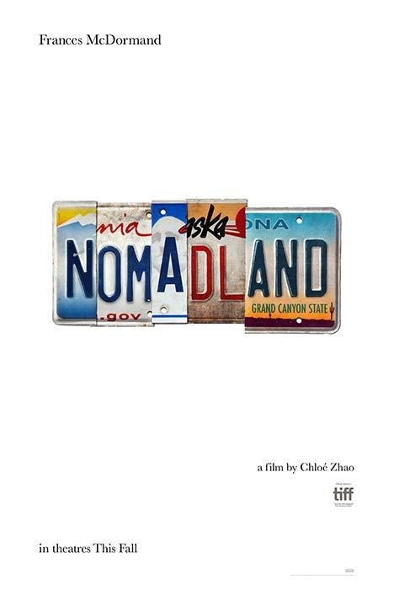

**Available on**: Hulu (soon Disney+)

**Release date:** February 2021

**Description:** A woman in her sixties who, after losing everything in the Great Recession (2008), embarks on a journey through the American West, living as a van-dwelling modern-day nomad.

**Reviews:** *McDormand gives one of the quietest, most powerful performances of her career as a woman living on and discovering the joys of the road in this affecting, memorable drama.* (Sandie Angulo Chen)

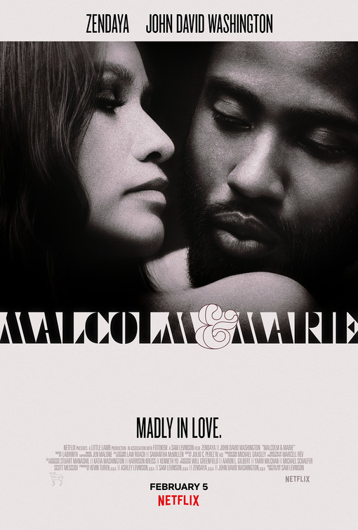

**Available on:** Netflix

**Release Date:** February 2021

**Description:** A filmmaker on the brink of Hollywood glory and his girlfriend, whose story made his career, find themselves pushed towards a reckoning as a single tumultuous night decides the fate of their relationship.

**Reviews:** *Zendaya and Washington were praised for their acting, however Levinson's screenplay has been heavily criticized.*

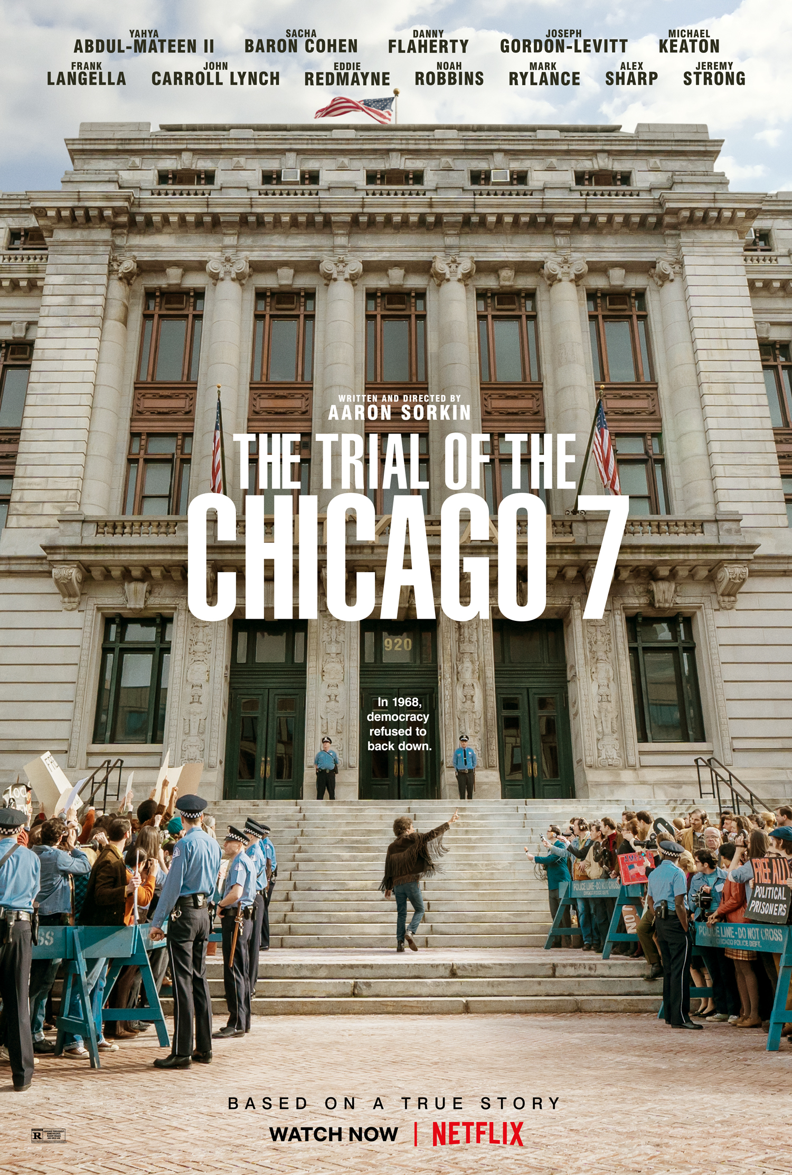

**Available on:** Netflix

**Release date:** October 2020

**Description:** The film is based on the infamous 1969 trial of seven defendants charged by the federal government with conspiracy and more, arising from the countercultural protests in Chicago at the 1968 Democratic National Convention.

**Reviews:** *The film’s intentions of sparking conversation about how far we’ve come since the riots of 1968 was effectively achieved with great performances and in addition, the timing of the film's release was perfect. As laws against protest movements in the United States gain traction and one of the most important elections in the country’s history was on the horizon.(Roger Ebert, Oct 2020)*

**Available on:** Amazon, Youtube, and Vudu 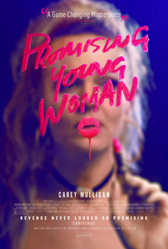

**Release date:** January 2020

**Description:** Nothing in Cassie's life is what it appears to be -- she's wickedly smart, and she's living a secret double life by night. Now, an unexpected encounter is about to give Cassie a chance to right the wrongs from the past.

**Reviews:** *A stylized film on a serious subject. A film that’s willing to be a little messy and inconsistent in a way that reflects Cassie’s existence. (Roger Ebert, Jan 2021)*

*Promising Young Woman is tragedy masked as comedy, a movie where an itch for justice is scratched by a twisted knife.* (Paul Asay)

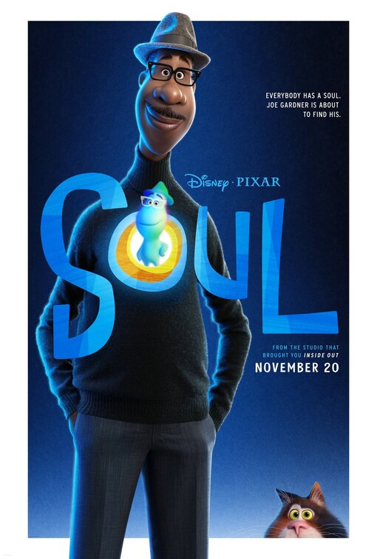

**Available on:** Disney+

**Release date:** December 2020

**Description:** A musician who has lost his passion for music is transported out of his body and must find his way back with the help of an infant soul learning about

herself.

**Reviews:** *Soul isn't Pixar's finest or most resonant film, but its beautiful animation and soundtrack, paired with fun characters make for an enjoyable watch.* (Molly Freeman)